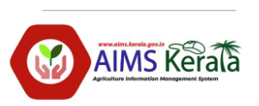

MES COLLEGE MARAMPALLY
COMPUTER LITERACY FORUM 2023-2024
Seminar On
“കർഷകർക്കൊരു കൈത്താങ്ങ്” On 16/03/2024
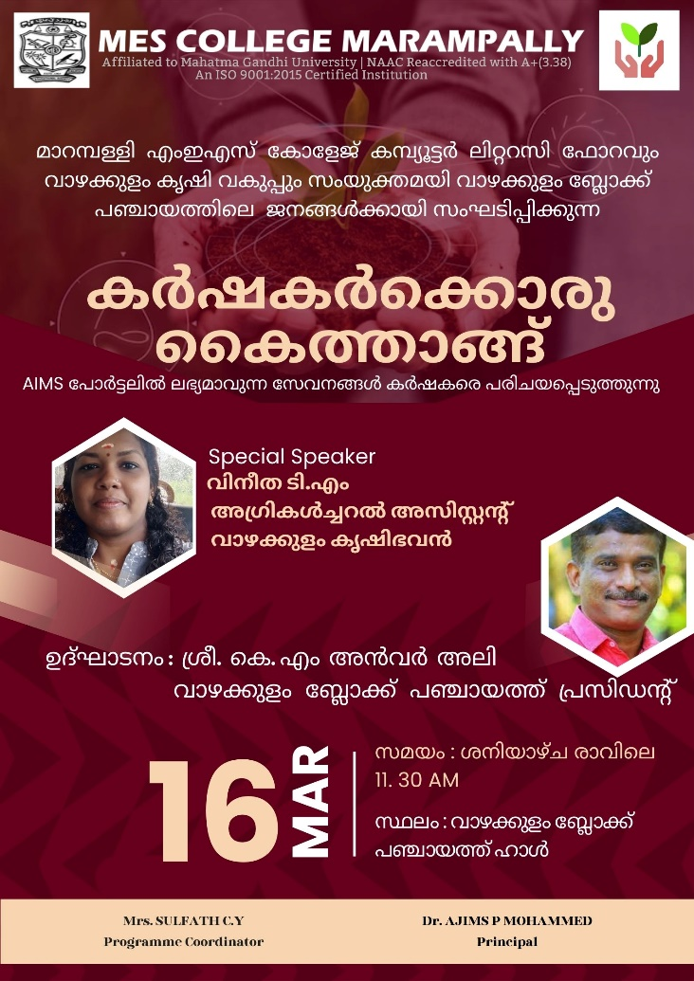

Computer Literacy Forum of MES College Marampally in association with Vazhakkulam Agricutural Section organized one-day seminar on the topic “കർഷകർക്കൊരു കൈത്താങ്ങ്” for the Farmers of Vazhakulam Block Panchayath on 16/03/2024.The objective of the programme is to give an awareness about the services currently available on the AIMS portal, services from the Department of Agricultural Development and Farmers' Welfare, State Government's Crop Insurance Scheme, Disaster Relief Scheme etc.
The programme started with a simple inauguration session. Mrs. Sulfath C.Y, Coordinator, Computer Literacy Forum welcomed the gathering. Dr.Ajims P Mohammed, Principal, MES College Marampally presided the inaugural session. Mrs. Aji Hakkim, Vice President, Vazhakulam Block Panchayath officially inaugurated the seminar and gave inaugural address. Mrs. Anita P Assistant Director of Agriculture Keezhmadu, Mrs. Sheeja Pulikal Member of Keermadu Division, Mrs. Faseela Begum BDO Incharge etc. extended their greetings. With the vote of thanks the inaugural session came to an end.
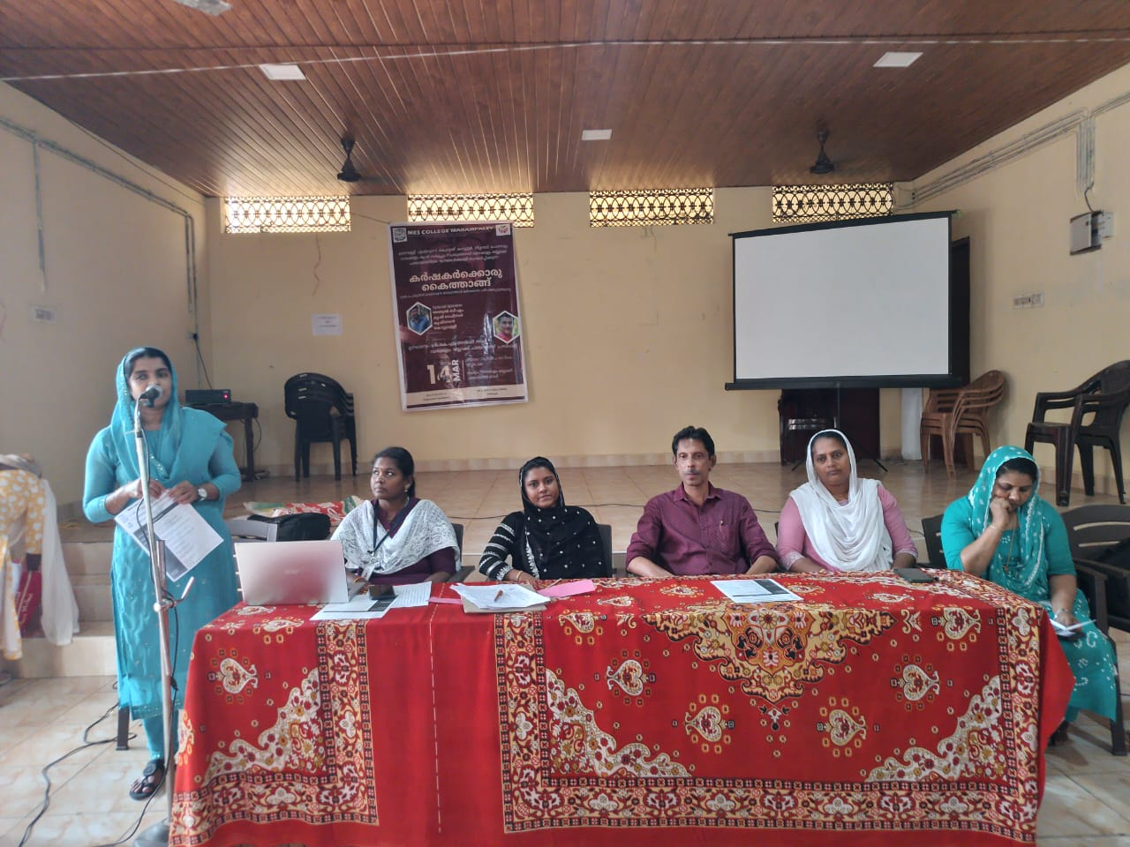
Mrs. Vineetha T.M, Agricultural Assistant,Vazhakulam Krishi Bhavan was the resource person. The seminar mainly focus on the services currently available on the AIMS portal, services from the Department of Agricultural Development and Farmers' Welfare, State Government's Crop Insurance Scheme, Disaster Relief Scheme etc. A total of 90 participants were attended. The seminar was very informative and effective. It creates an idea about innovative AIMS portal services. The programme started at 11.30am and concluded by 2.30 pm with a simple valedictory function. Feedback was taken from the participants.

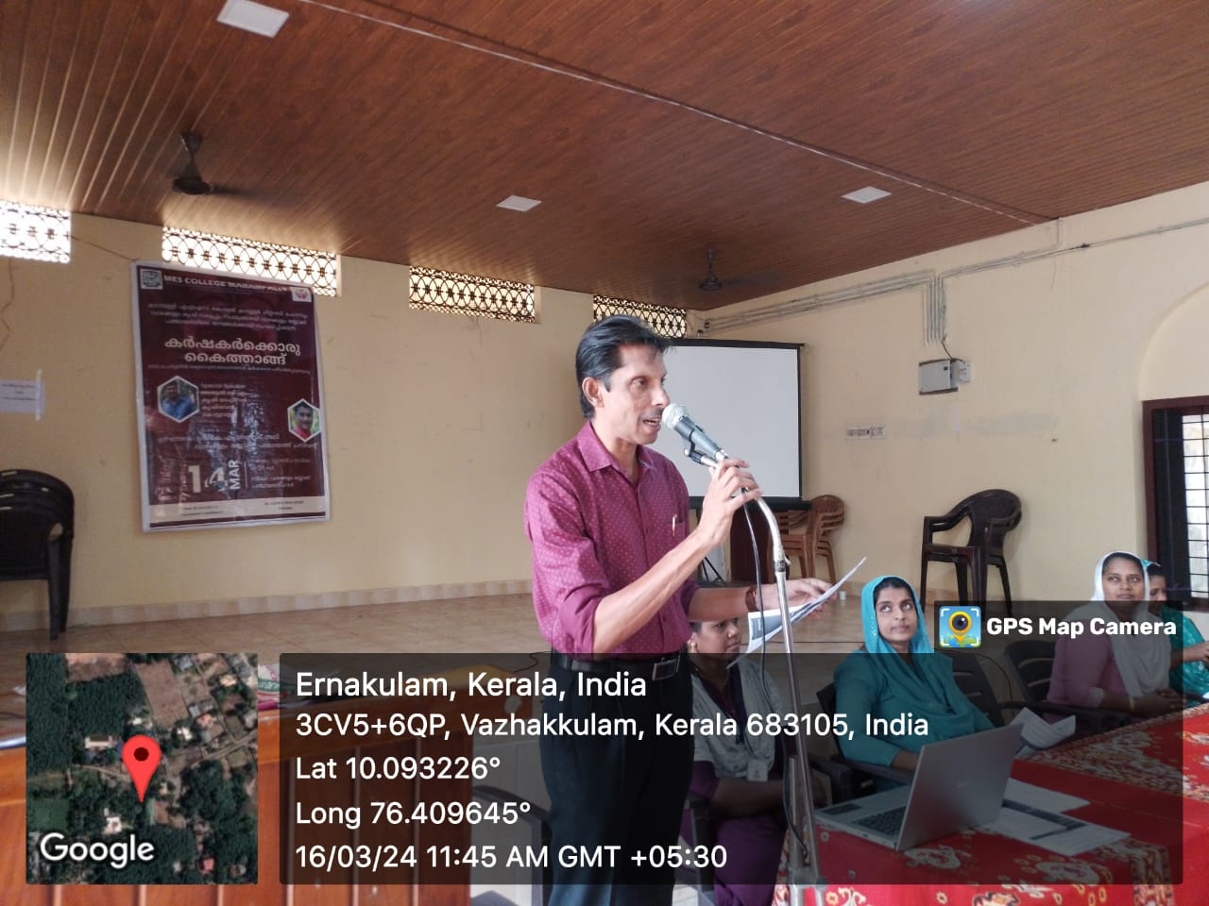

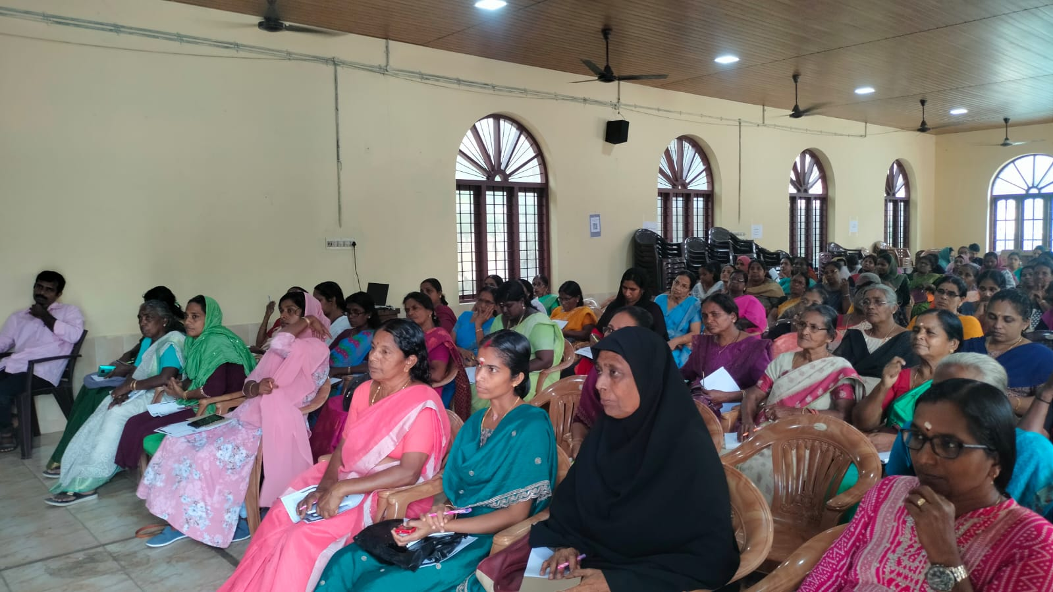

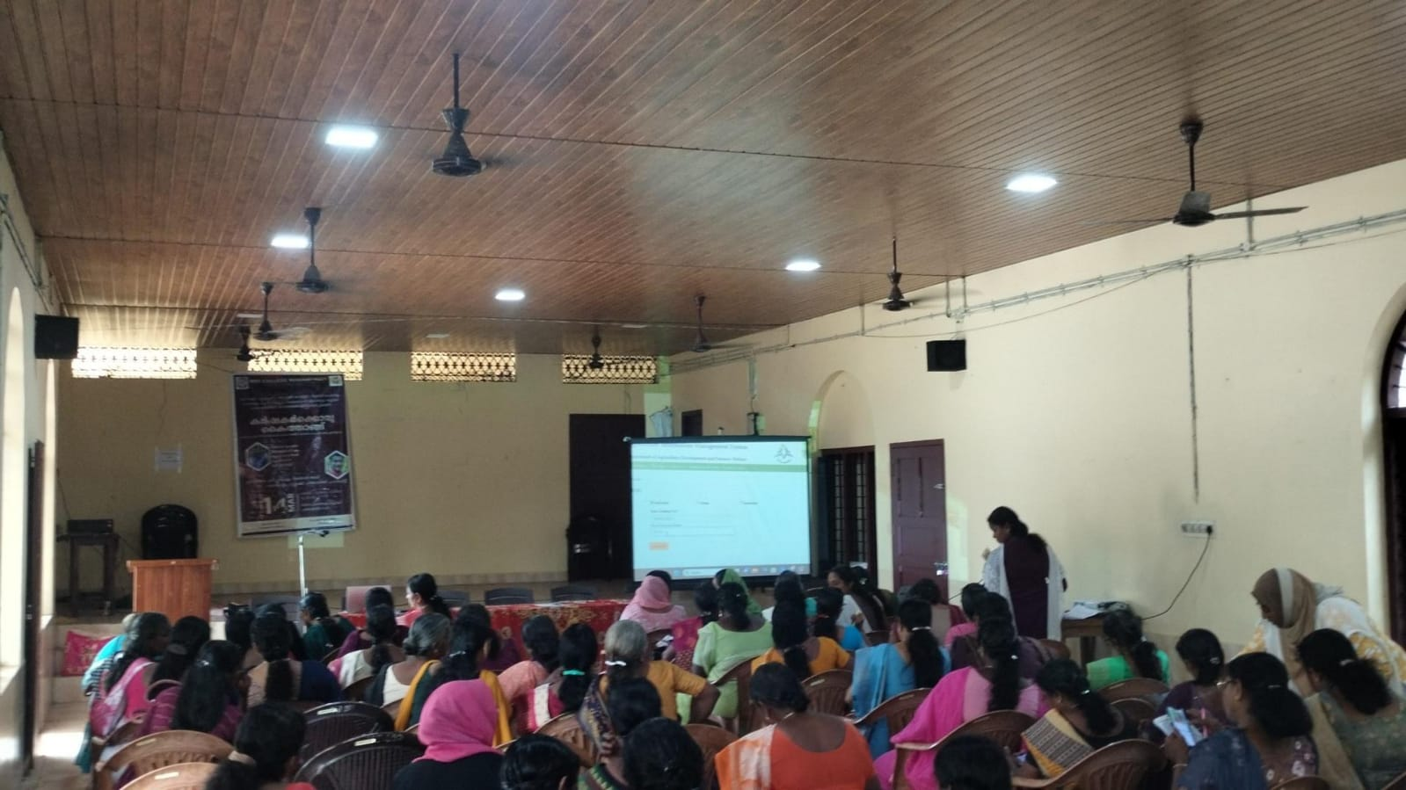

SULFATH C.Y
Computer Literacy Forum
MES College Marampally

